**1. Introduction**

1.1 Purpose

This manual is aiming to let the readers know how to use the GreeNews App.  
1.2 Project Background

Development unit: SDBSE CQU 20161669  
1.3 Definitions

Null

1.4 Reference

Null  
**2. Overview**2.1 Aims

To show readers the news about environmental protection.  
2.2 Function

Login your own account to collect and comment the news.   
2.3 Performance

Entire performance: Low  
    a.数据精确度【包括输入、输出及处理数据的精度】  
    b.时间特性【如响应时间、处理时间、数据传输时间等。】  
    c.灵活性【在操作方式、运行环境需做某些变更时软件的适应能力。】  
  
**3. Operating Environment**3.1 Hardware

    【列出软件系统运行时所需的硬件最小配置，如

           a. 计算机型号、主存容量；

           b. 外存储器、媒体、记录格式、设备型号及数量；

           c. 输入、输出设备；

           d. 数据传输设备及数据转换设备的型号及数量。】  
3.2 Software

    【如：a. 操作系统名称及版本号；

          b. 语言编译系统或汇编系统的名称及版本号；

          c. 数据库管理系统的名称及版本号；

          d. 其他必要的支持软件。】  
  
**4. Instructions**4.1 Installation and initialization

1. Run the GreeNews.apk and press INSTALL. 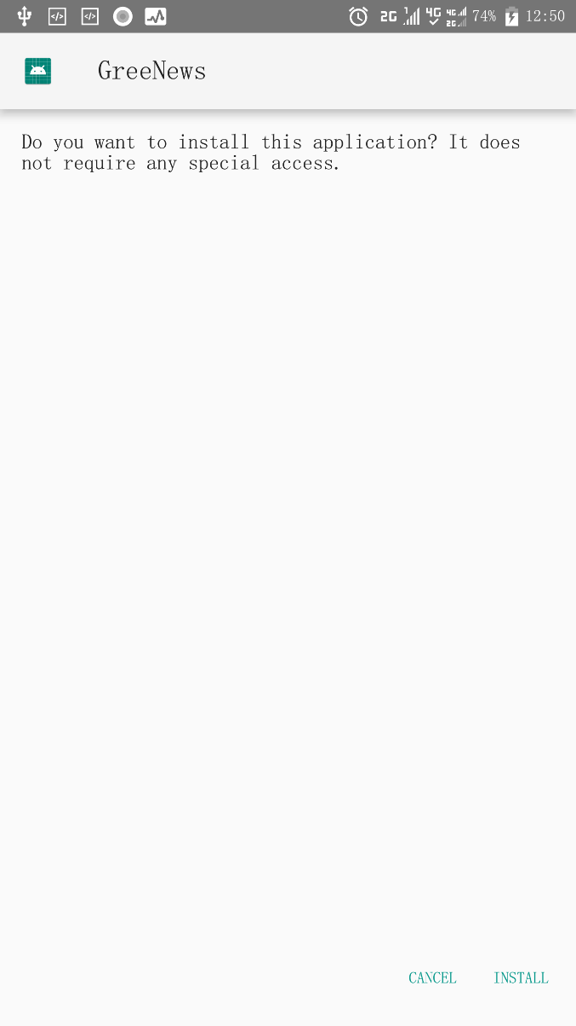
2. Press OPEN to run the application

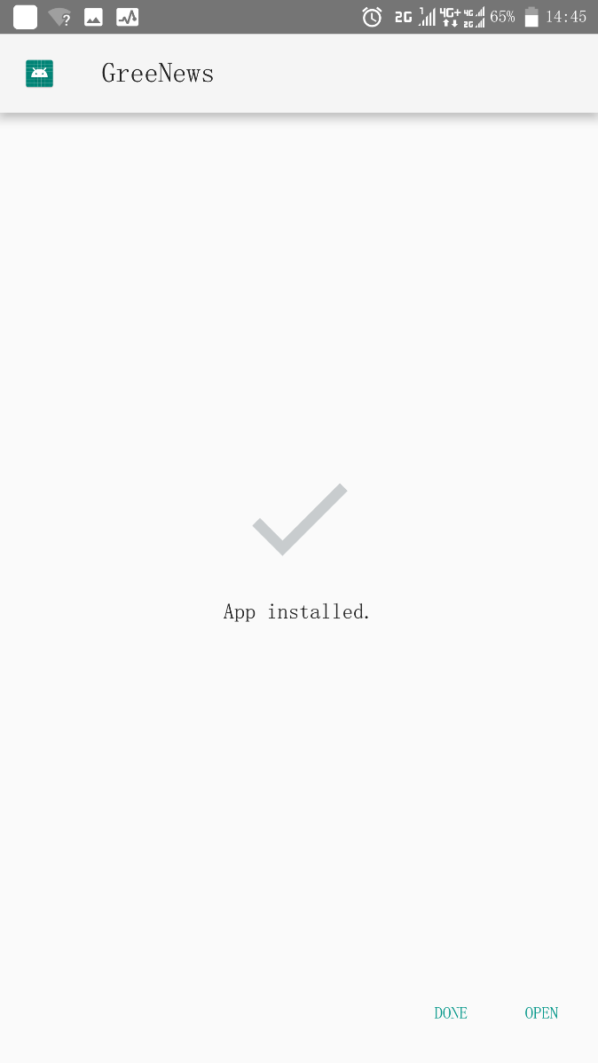

4.2 Sign up & Login

a. SignUpActivity: Sign up for your own account.

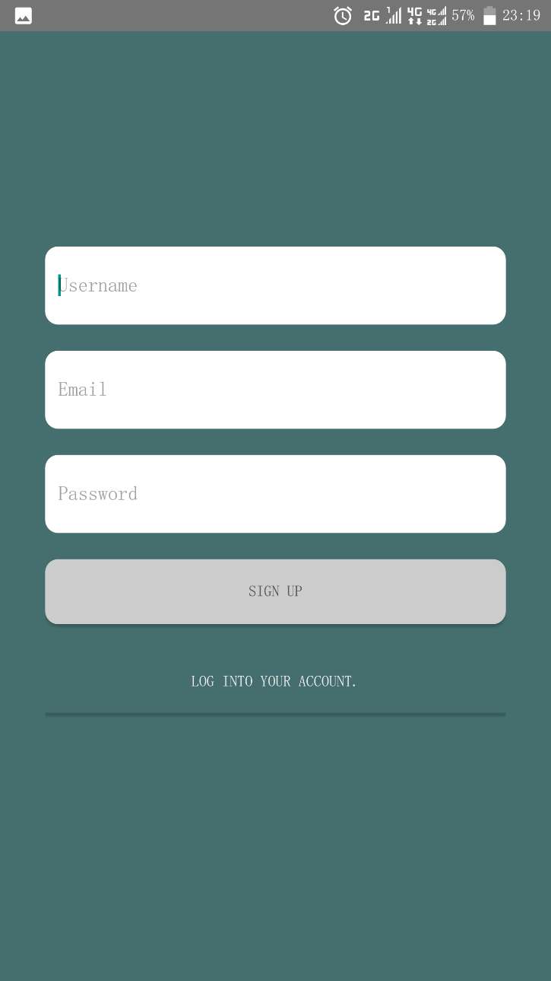

b. LoginActivity: Login to your account.

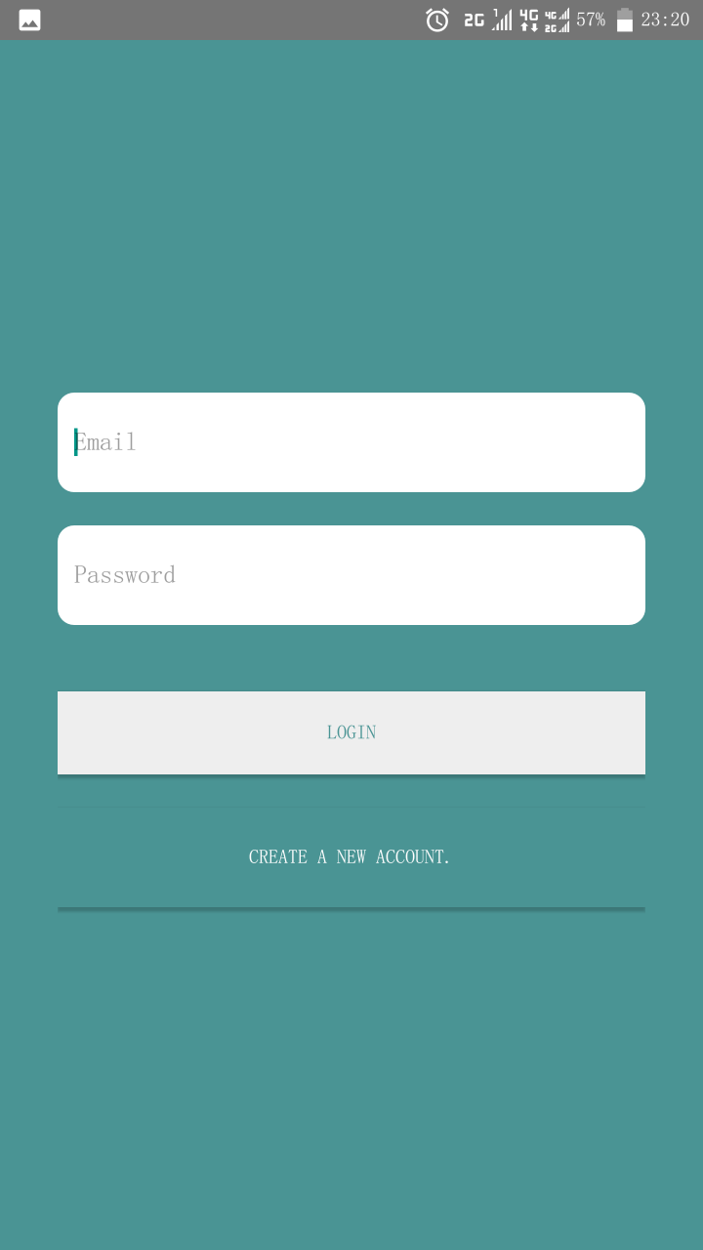

4.3 Main Function

1. HomeActivity: Show a list of outlines of Newses

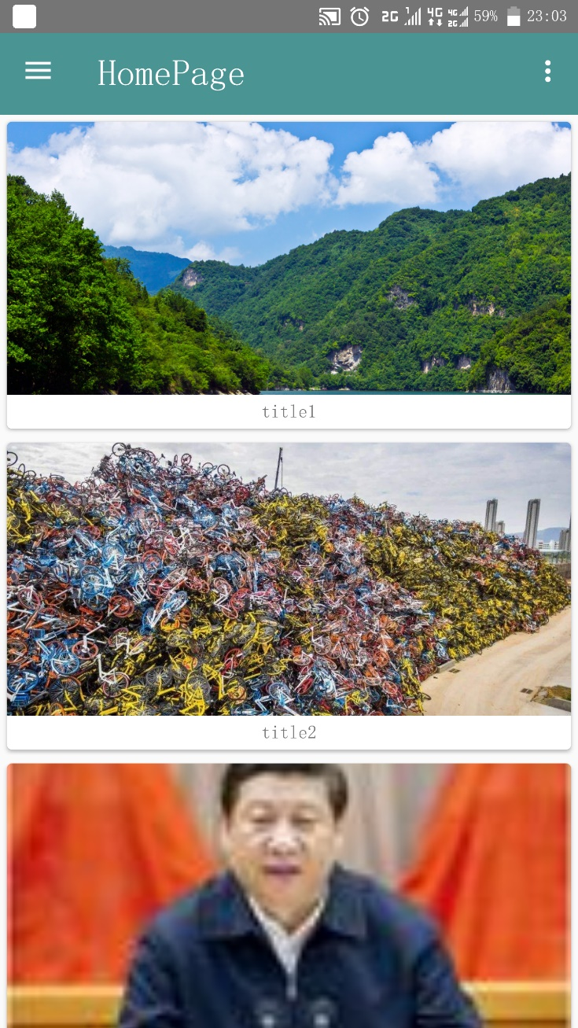

1. Drawerlayout : Can do a variety of operations and view a lot of information



1. Item profile: to show the comments and likes you’ve received.

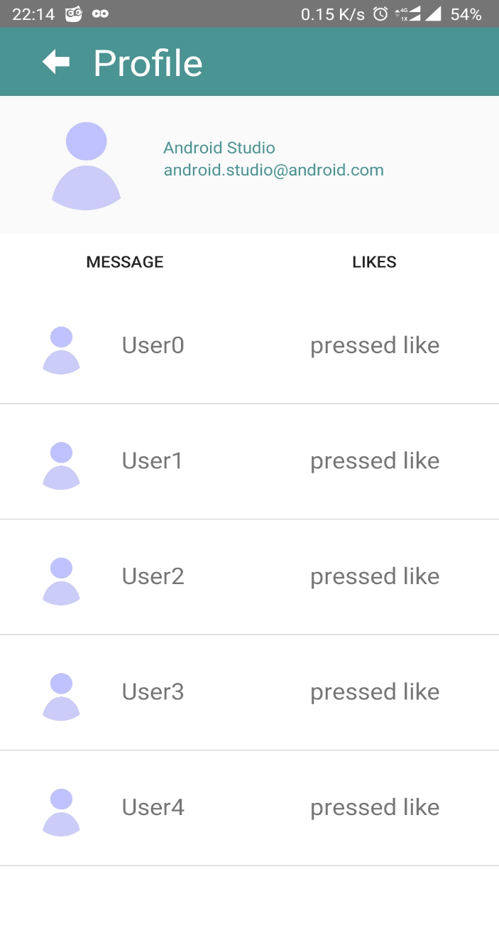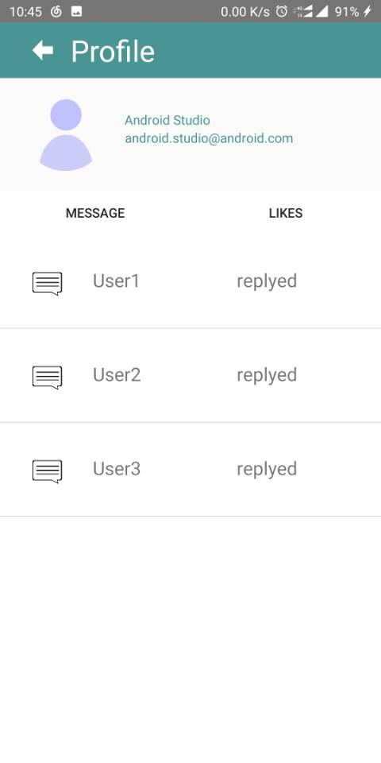

1. Item Favorito: to show the articles you pressed like.

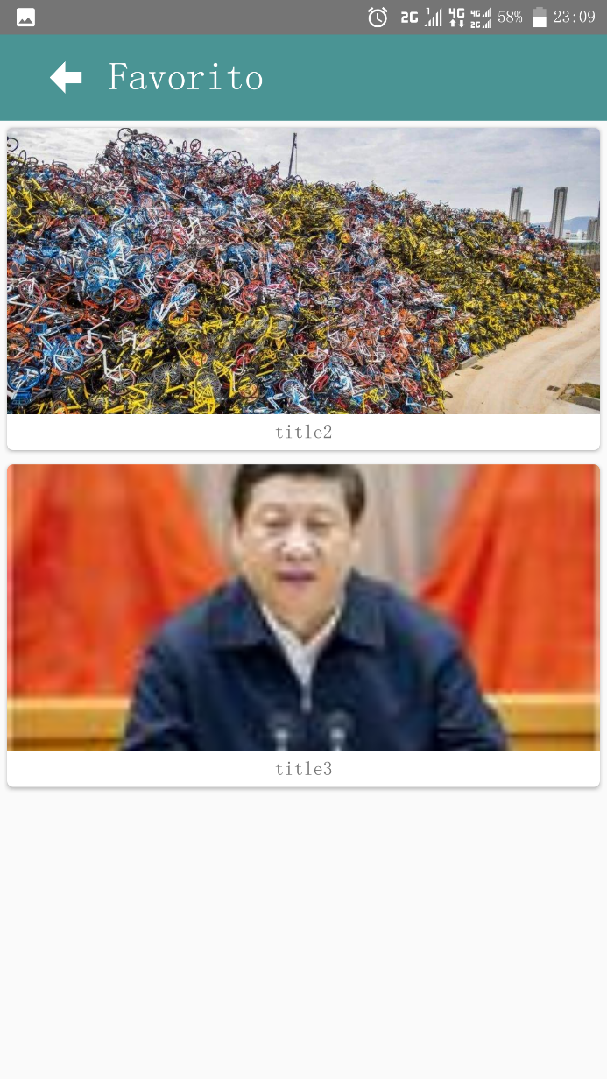

1. Item Posts: to show the comments you posted.

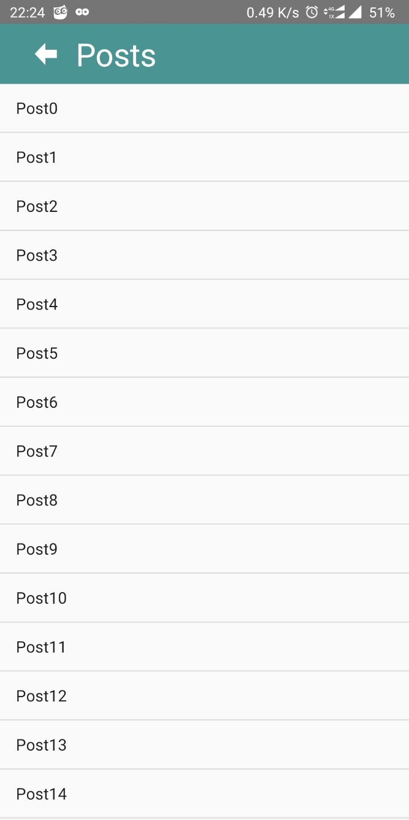

1. Item Settings: to show the setting switches.

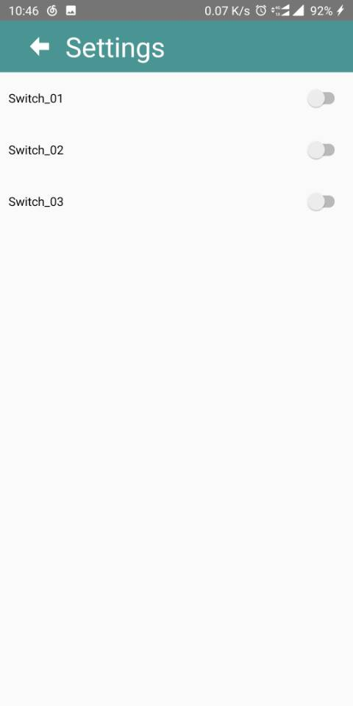

1. Item Help Center: to show the helping center selectios.

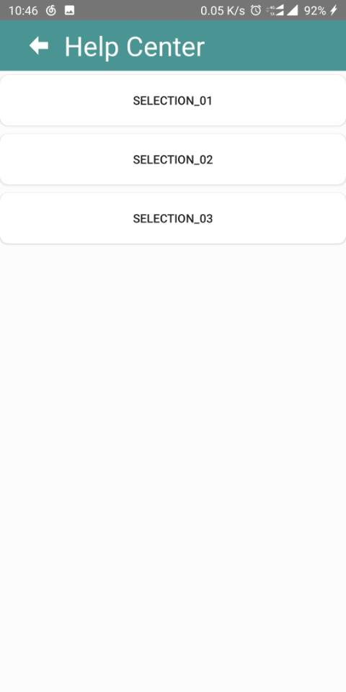

4.4 Article

a. ArticleActivity: to show the news by webview

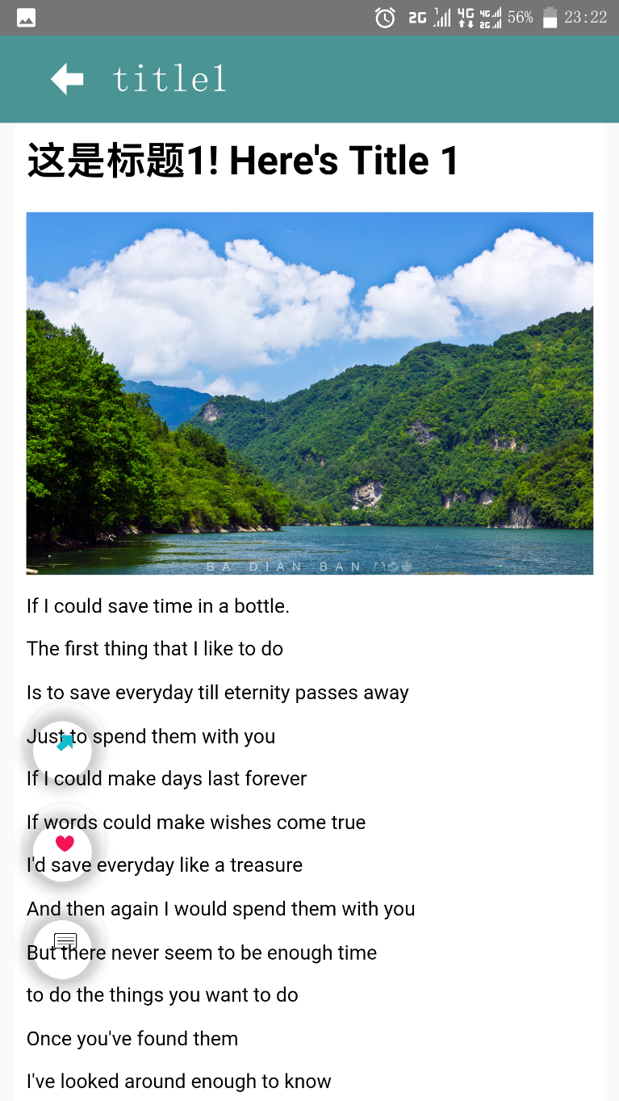

**5.Perfomance**

5.1 Entire functional performance: Low